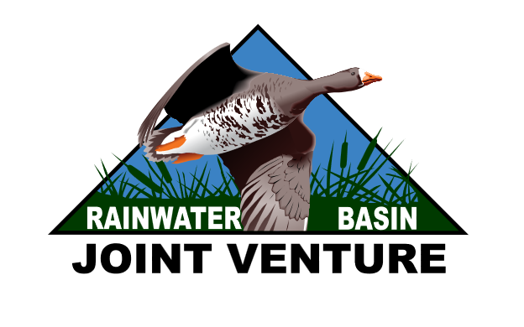
Spatial Database for Regional Conservation Partnership Program (RCPP): 3835 - Growing and Expanding Nebraska's Grassland Cores
  - Rainwater Basin Joint Venture, Grand Island, Nebraska
For technical inquiries, contact Roger Grosse (Roger_Grosse@fws.gov)

Introduction
The spatial database for entering RCPP is hosted on USFWS ArcGIS Online (AGOL) platform to facilitate cross-agency/entity delivery planning and administration. Delivery staff can join the RCPP AGOL group using any agency/organizational AGOL account. If a delivery partner does not possess or cannot use their organizational AGOL account for any reason, a USFWS collaborator AGOL account can be provided. To join the AGOL group, please contact Roger Grosse and provide your AGOL account information. With many users having access to a singular tracking database, polygons are only visible by the data creator and the group managers to avoid accidental deletion or modification of others data. Feel free to enter test projects to familiarize yourself with the system, but please mark the feature for deletion in the associated attribute table, and the data management team will periodically back up data and perform necessary feature deletion. The data hosted on USFWS AGOL will be transitory and will be removed when the RCPP has concluded. The data will be permanently archived in the Rainwater Basin Joint Venture (RWBJV) Project and Management Tracking Database. Users will be able to export the data pertaining to their projects through the duration of the RCPP or can request copies of their data from the RWBJV after the cessation of the RCPP for their own record keeping.
There are two feature layers that will store the RCPP tracking information: RCPP Project Boundaries and RCPP Project Practices. RCPP Project Boundaries identifies the project area and contains general information about the site, delivery point of contact, and contract/agreement. RCPP Project Practices contains information specific to practice delivery within project areas. The preferred workflow is to enter the initial project information via the Survey123 form and any subsequent edits to the project boundary and practices can be entered via the ArcGIS Pro Project (.aprx) provided. The aprx contains additional data layers that may help delivery planners determine practice scenario application and also a map package production tool that will export a series of map pages for inclusion in the landowner contract, including estimated cost based on the practice scenarios delineated in RCPP Project Practices.

Data Entry Instructions
Please note: In addition to this text description, an example of the data entry process was recorded in multiple part videos.

Part 1 – Exploring the RCPP3835.aprx ArcGIS Pro Document

The first part is completed externally to ArcGIS, but feel free to open the RCPP3835.aprx to reference the location and other information for your project. This ArcGIS Pro project has all the primary and ancillary data needed to complete the Survey123 form. The RCPP3835.aprx is your local copy, feel free to modify it as you wish. The other ArcGIS Pro Project (RCPP3835_Map_Portfolio.aprx) contains the standardized map template for the map outputs, please do not alter or change the relative location of this map project.

The following are a list of required layers for completion:
Project Boundaries – This will initially be drawn in Survey123, but can be modified after if needed.
Practice/Scenarios (Cost Share [314,338,528,595]) - These will be drawn after the Survey123 process through the RCPP3835.aprx
Practice/Scenarios (Non-Cost Share [394]) - Firebreaks [394] are not eligible for cost-share through the RCPP, but the firebreak locations were requested by NRCS to facilitate review of the prescribed fire practice [338].
Structures – Another request on behalf of NRCS to facilitate project review. Please identify any standing/historic structures relevant to the project corresponding to the resources identified in the Survey123 process.
The following are layers that will inform planning requirements but are not required to edit:
Tribal Lands – Also related to the question within Survey123. Projects delivered on tribal lands require an additional form completed and included in the application
RCPP Tiers – Document the tier (1,2, or 3) the project falls into. Only Tier 1 & 2 are eligible unless adjacent to a prior project (2020-25) or within a wildfire perimeter from spring 2026. Tier 3 projects falling into the latter exceptions are considered Tier 2.
GPGI plus Loess Hills Area – The first year, due to T&E species considerations, RCPP eligible projects will be limited to the GPGI and Loess Hills priority areas. Please verify eligibility for year one.
State and Federal Species Ranges – Selecting your project boundary, then using select by location on both range layers using your project boundary as the selecting feature will identify which species ranges need to be considered when evaluating the project (see video for part 2 for demonstration).
Prior projects (2020-25) - Prior projects from 2020-25. Tier 3 areas adjacent to prior projects become eligible as Tier 2. If prior projects are missing that would make an area eligible, please provide prior project information to RWBJV GIS staff.
Fire perimeters (2026) - Wildfire perimeters from spring 2026. Tier 3 areas within the perimeters become eligible as Tier 2.
The following are optional layers that may facilitate project planning, but are not required to be used:
Slope – May help delineate slope dependent practice scenarios

Part 2 - Survey123 Data Entry
The project boundary information will be populated through the online Survey123 mapping portal and the corresponding practice information will be recorded in ArcGIS Pro. The responses to the Survey123 questions are stored with the project boundary, therefore it is advisable to use the web entry to produce the project boundary, however there is a process to enter the project location through Survey123 and modify that boundary using existing files. Because the practice-scenario information doesn’t contain Survey123 data, it can be copied easily from existing feature classes.
Step 1: Start by navigate to the RWBJV RCPP 3835 Growing and Expanding Nebraska’s Grassland Cores Survey123 form using this link. The first question asks you to enter the project boundary using the interactive map. You can search a location in the search box or navigate using the navigation tools along the left. The lower left button will make the map full size. You can change the reference layers (including imagery) with the upper right button. The lower right button will allow you to draw the project boundary.
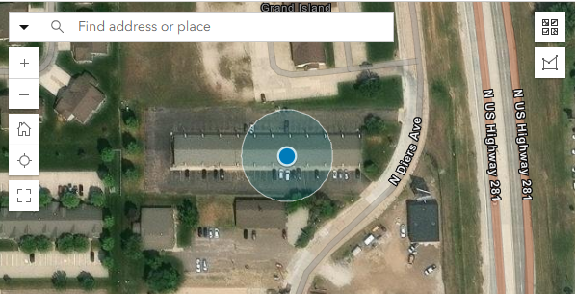

Step 2: The next several questions capture some basic information about the project:
Project Planning Date - Typically the date of entry
Agreement/Contract ID - Can be a formal or informal agreement ID (as long as it is unique). The purpose of this question is to identify the project with something other than the landowner’s name to allow the landowner to enter into more than one project agreement and retaining the ability to keep the agreements distinct from one another.
Project Name - As the question implies the name of the project, typically the landowner’s name.
Project Status - The current phase of project delivery. At this point in project development, it will most likely always be ‘Planning/agreement phase’, but please update the layer attributes (can be performed later in ArcPro) throughout the project lifecycle.
County - Given the project will have spatial location, this will just be used to populate the header information for subsequent mapping purposes.
Legal Description - As prior question, this is how the legal description will appear in the header information. The level of detail and formatting describing the site is entirely up to the conservation partner.
Contact - The partner point of contact name, also for subsequent header data. The person who entered the data is also automatically recorded in another attribute.
Contact Org - The corresponding affiliate organization(s) of the contact partner.
RCPP Tier - The tier identified by the conservation partner. The preliminary tier designations provided in the aprx are based on remotely sensed Rangeland Analysis Platform (RAP) data, which may have substantial errors at the local scale. If a Tier 3 site is identified, the site must be adjacent to previous project delivery area (core expansion) within the last 6 years (2020-25). Site level evaluation will be accepted, superseding the data layer with proper documentation. Please see the Partnership Delivery 2020-25 layer (RCPP3835.aprx) for prior project delivery locations. If prior project data has been omitted, please contact Roger Grosse with prior spatial records.

Step 3: The next set of questions is intended to help NRCS facilitate Historic and Cultural Resources review. Please answer the questions for the associated management practices that will be used in conjunction with project delivery. Please skip or otherwise leave non-applied practices blank. Based on these responses, different types/levels of review may be required. The map generation tool will identify these review requirements for inclusion in the agreement, but NRCS staff will perform all necessary review actions, and will not be the responsibility of the landowner or conservation partner staff. NRCS staff will communicate any special considerations determined during the review process to delivery staff and the landowner prior to final agreement.

Step 4: The next set of questions will help determine conservation measures for endangered and threatened state and federally listed species. You can use the species range layers in the RCPP3835.aprx ArcGIS Pro project document to identify which species ranges are present for your project. Fill out the questions for each species, the mapping application will output responses and conservation measures. The mapping process will filter out which species do not apply and will produce a range map for each species with your project boundary and the conservation measures required based on the question responses.

Part 2 - Entering Practice Information in ArcGIS PRO
Open the provided RCPP3835.aprx and make sure you are signed in to your AGOL account associated with the RCPP group. You’ll notice that the project(s) boundaries you provided in the first part are contained in the ‘Project Boundary’ layer. You can zoom or otherwise navigate to a specific project and use the editing ribbon/templates to add practices and scenarios.
To create/edit practice layers, turn on the layer you wish to edit and open the Edit tab and select Create. This will open a Create Features window. In the Create Features window, select the practice scenario you want to create the polygon for, then proceed to drawing the polygon in the map. There are many additional editing tools available to modify polygons.
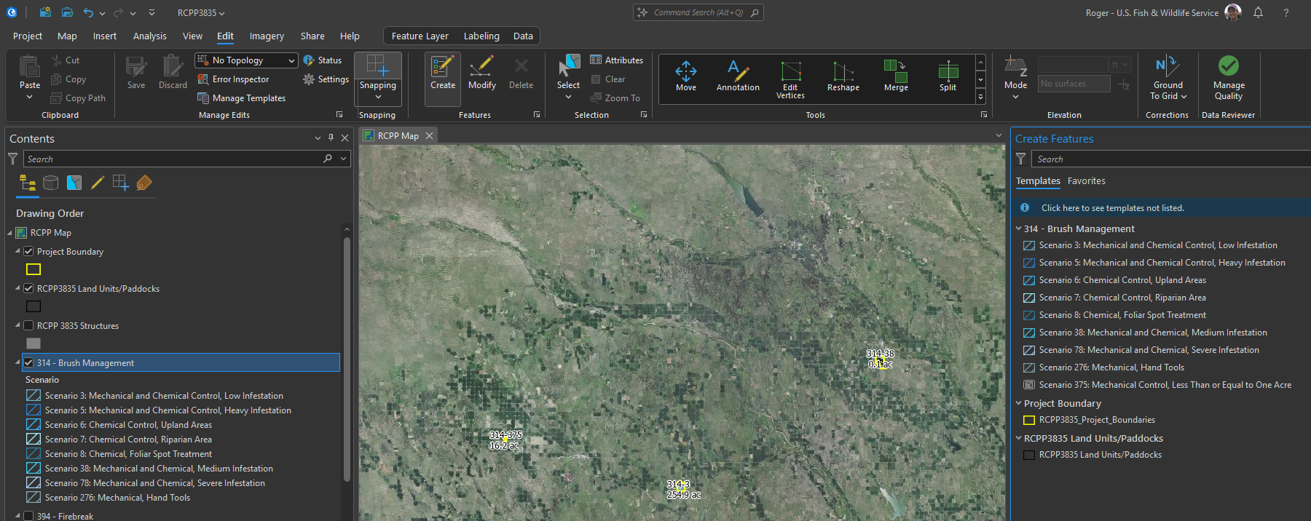
You’ll also notice there are some additional layers in the table of contents related to slope and RAP defined encroachment status. These may assist in identifying appropriate practice scenarios, but you are by no means obligated to use these supplemental layers, with some exceptions: 1) if working on a project with prescribed fire please add the location of known firebreaks and 2) please add the location of known structures. No additional attributes are required for these 2 layers, simply identifying the location will assist NRCS practices and regulatory review.

Part 3 - Update Attributes Through Project Lifecycle
Be sure to update the project information throughout the lifecycle of the project. The appendix has a list of fields that are required for a record to be considered complete. The software will not prompt you of all incomplete fields, as some field are not expected to be unknown at the time of project initiation (e.g. field work start and end dates). If possible, please update start and completion dates for each practice, as well as the project overall. There is a table at the bottom of each practice page in the map outputs where completion date documentation and practitioner verification is required. The JV staff will transcribe from contracts, but updating the spatial files will make it easier on staff and help ensure that the information is retained. The data management team will follow up periodically with contacts to verify completeness and identify missing information.

Map Portfolio Production
After completing data entry part 2, you will be ready to generate the map portfolio that will be included in the agreement. There are several ways of locating the RCPP Portfolio Tool, here are a couple options: 1) On the Analysis tab, select Tools and simply search RCPP in the Geoprocessing window that subsequently opens. 2) On the View tab, select Catalog Pane and expand the Toolboxes tree (both options are shown below). 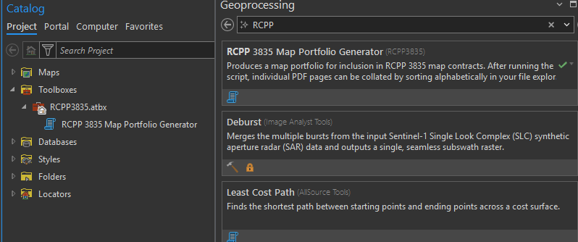
Navigate to the RCPP 3835 Map Portfolio Generator toolbox script. The tool will prompt the user to enter an Agreement ID, this can be copied from the Project Boundary attributes (Agreement IDs should be unique). The tool will begin generating a series of PDFs in the location of the aprx. This will take several minutes to complete, so please be patient while the maps are produced. When the script indicates it is finished, please review the PDF outputs. If sorted alphabetically by name, the pages should be collated in proper sequence and can be combined with Adobe Acrobat Pro or another preferred program. If you do not have access to Acrobat Pro, you are welcome to send all the pages to the data management team to combine to a single PDF.

RCPP Spatial Links
ArcGIS Online (AGOL) RCPP Delivery Partner Group:
https://arcg.is/u4HHn0

RCPP Survey123 (Project Boundary Delineation and Resources/ESA questionnaire):
https://survey123.arcgis.com/share/289d77f174a3474bb98221881a3c1349

RCPP Project Boundaries:
https://arcgis.com/home/item.html?id=18ebee55a68a40d18db8cb8189f13c3c&sublayer=0

RCPP Project Practices:
https://arcgis.com/home/item.html?id=9c4565a5d0d14149b9b07986c8c75b7a&sublayer=0

Attribute Descriptions

RCPP Project Boundaries
Attribute Name | Field Type | Coded Values | Description
PlanningDate* | Date | N/A | Date the conservation practitioner developed the delivery plan.
AgreementID* | Text | N/A | Agreement/application identifier.
AgreementDate* | Date | N/A | Date all parties agreed/signed the project contract.
ProjectStatus* | Text | Planning | The project is in the planning or agreement phase, but work has not begun.
ProjectStatus* | Text | In-Progress | Initial work has been performed, but not all phases of the current project agreement have been completed (e.g. multi-year agreements).
ProjectStatus* | Text | Complete | All phases and terms of the project agreement have concluded, and the associated records are complete.
CompletionDate* | Date | N/A | Date all phases were verified complete
ProjectName* | Text | N/A | Name of the project.
County** | Text | County Names | Name of the county where the project is located.
Legal** | Text | N/A | Legal description.
Contact* | Text | AGOL User ID (Overwritable) | Name of the conservation practitioner who is lead for the project. Can be overwritten in cases of staff turnover or geospatial user is not the delivery lead.
ContactOrg* | Text | N/A | Name of the lead/contact organization.
GISAcres* | Float | N/A | GIS calculated acres.
RCPPTier* | Integer | 1 | <10% tree cover, single treatment
RCPPTier* | Integer | 2 | 65 to 90% herbaceous grassland cover, double treatment
Notes | Text | N/A | Any additional information that the conservation practitioner would like to record.
DeleteStatus | Text | Delete | The data management team will delete the feature/record.
DeleteStatus | Text | Retain | The feature is to be retained.
*Required to be a complete record. All information may not be available at the time data is initially entered. The conservation practitioner is responsible for updating records to meet completion requirements.
**This is only recommended to facilitate mapping (map headers). Omissions of this attribute will not be considered an incomplete record because county name and legal description can easily be identified based on spatial location.

RCPP Project Practices
Attribute Name | Field Type | Coded Values | Description
GISAcres* | Float | N/A | GIS calculated acres. These will get populated
StartDate* | Date | N/A | Date on-ground practice delivery was initiated (best estimate).
EndDate* | Date | N/A | Date on-ground practice delivery was concluded (best estimate).
DateConfidence* | Text | Day | The start and end date provided are accurate to the day.
DateConfidence* | Text | Month | The start and end date provided are accurate to the month.
DateConfidence* | Text | Season | The start and end date provided are accurate to the season (+ or - 2 months).
DateConfidence* | Text | Year | The start and end date provided are accurate to the year.
AgreementID* | Text | N/A | The agreement ID that corresponds with the practice. Project name and spatial correlation will not suffice as there may be subsequent RCPP contracts that cover follow up treatments independent of the initial contract.
ReportAmount* | Float | N/A | The amount of any given units identified in the contract. Typically number of acres which gives an opportunity to record discrepancies between GIS calculated area and field estimates.
ReportedAmountUnits* | Text | N/A | Units from the associated with the prior ‘ReportedAmount’ field, typically acres.
Contact* | Text | AGOL User ID (Overwritable) | Name of the conservation practitioner who is project lead. Can be overwritten in cases of staff turnover or geospatial user is not the delivery lead.
PracticeCode* | Text | 314 | Brush Management
PracticeCode* | Text | 338 | Prescribed Fire
PracticeCode* | Text | 394 | Firebreak
PracticeCode* | Text | 528 | Prescribed Grazing
PracticeCode* | Text | 595 | Pest Management Conservation System
PracticeCode* | Text | 666 | Forest Stand Improvement
Scenario* ** | Text | 1 | Applicable practices: 338
Scenario* ** | Text | 2 | Applicable practices: 394
Scenario* ** | Text | 3 | Applicable practices: 314
Scenario* ** | Text | 5 | Applicable practices: 314
Scenario* ** | Text | 6 | Applicable practices: 314
Scenario* ** | Text | 7 | Applicable practices: 314
Scenario* ** | Text | 8 | Applicable practices: 314, 528
Scenario* ** | Text | 38 | Applicable practices: 314
Scenario* ** | Text | 39 | Applicable practices: 528
Scenario* ** | Text | 66 | Applicable practices: 338
Scenario* ** | Text | PR 66 | Applicable practices: 338
Scenario* ** | Text | 68 | Applicable practices: 338
Scenario* ** | Text | 69 | Applicable practices: 338
Scenario* ** | Text | 78 | Applicable practices: 314
Scenario* ** | Text | PR 78 | Applicable practices: 314
Scenario* ** | Text | 194 | Applicable practices: 595
Scenario* ** | Text | 276 | Applicable practices: 314
Scenario* ** | Text | 375 | Applicable practices: 314
Notes | Text | N/A | Any additional information that the conservation practitioner would like to record.
DeleteStatus | Text | Delete | The data management team will delete the feature/record.
DeleteStatus | Text | Retain | The feature is to be retained.
*Required to be a complete record. All information may not be available at the time data is initially entered. The conservation practitioner is responsible for updating records to meet completion requirements.
**Coded values available dependent upon previous ‘PracticeCode’ selection. For a description of each scenario, see RCPP application guidance.

